1.wite a c++ program for eligible for vote?

Condition-1:the value should be integer.

Condition-2:the number should be positive number?

PROGRAM:

using namespace std;

#include<iostream>

int main()

{

int age;

cout<<"enter the age";

cin>>age;

if(age>0 && int(age))

{

if (age>=18)

{

cout<<"eligible for vote";

}

else

{

cout<<"not eligible";

}

}

else

{

cout<<"not valid";

}

}

OUTPUT:

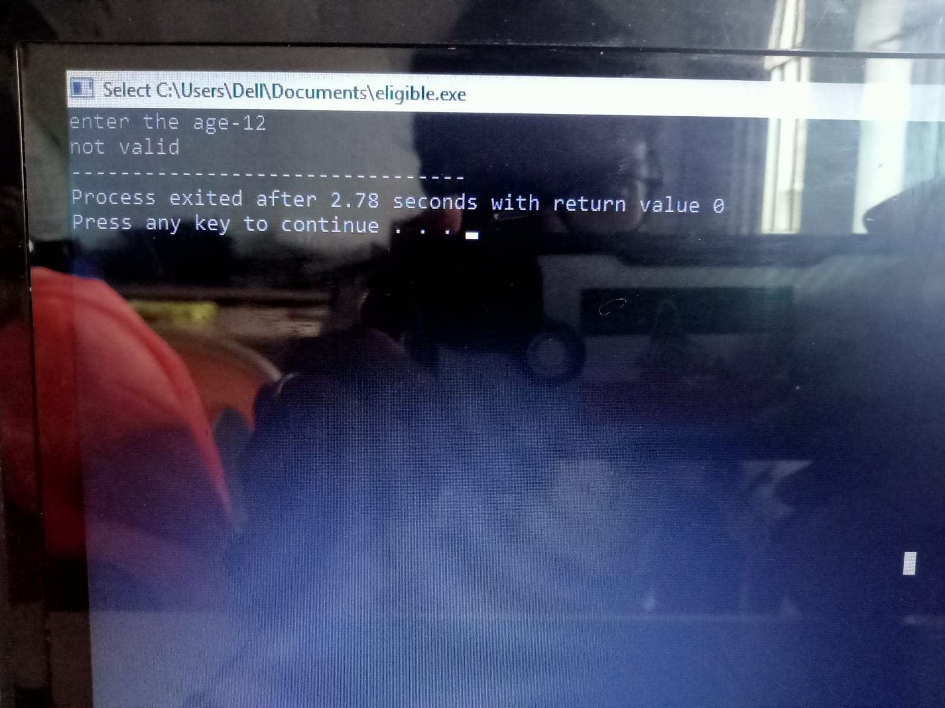

2.write the c++ program to show that the given number is even or odd ?

Condition 1:it should be integer number.

PROGRAM:

using namespace std;

#include<iostream>

int main()

{

int num,a;

cout<<"enter the number";

cin>>num;

if (int(num))

{

if(num%2==0)

{

cout<<"even number";

}

else

{

cout<<"odd number";

}

}

else

{

cout<<"not valid";

}

}

OUTPUT:

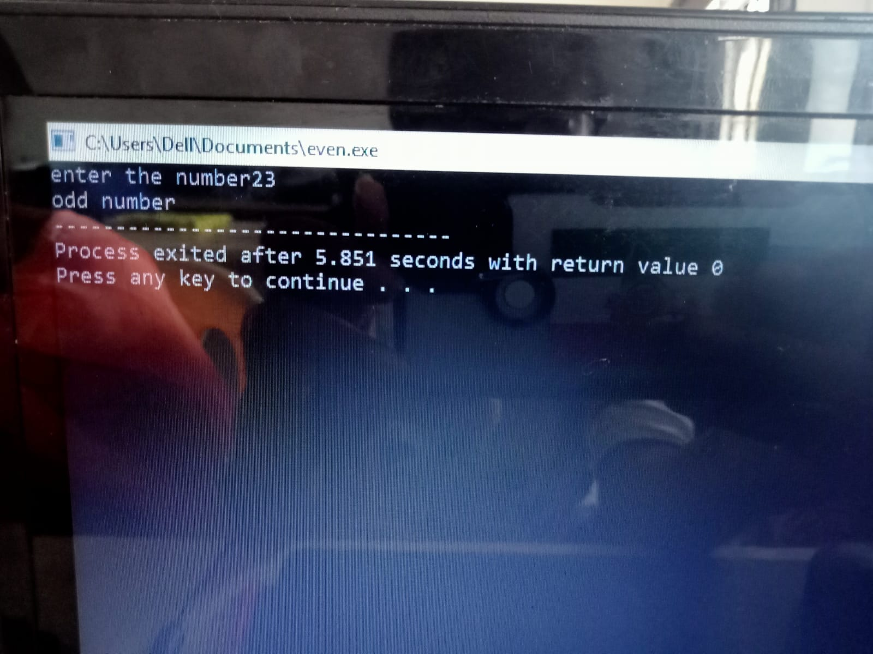

3.Write the c++ program to find the area of the circle and circumference of the circle using switch case statement?

PROGRAM:

using namespace std;

#include<iostream>

int main()

{

float r,PI=3.14;

int exp;

cout<<"enter the radius";

cin>>r;

cout<<"enter the choice";

cin>>exp;

switch(exp)

{

case 1:

{

cout<<"area"<<3.14\*r\*r;

break;

}

case 2:

{

cout<<"circumference"<<2\*3.14\*r;

break;

}

default:

{

cout<<"enter the correct choice";

}

}

}

OUTPUT:

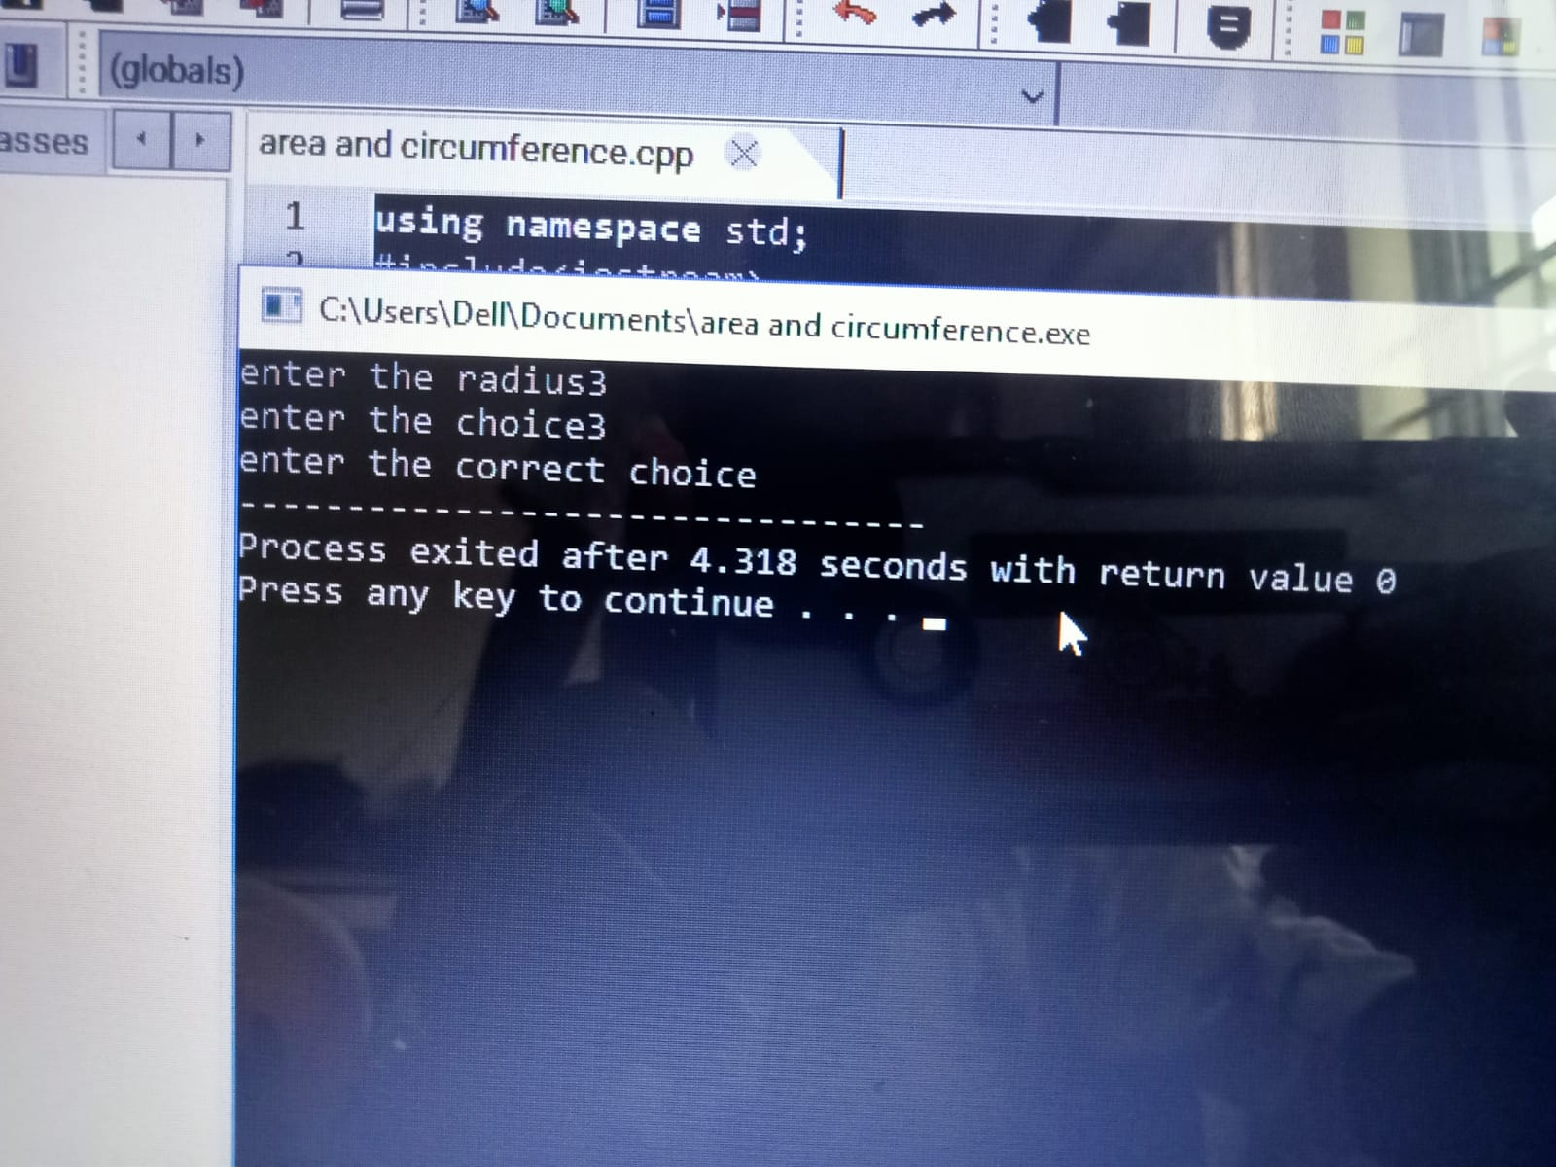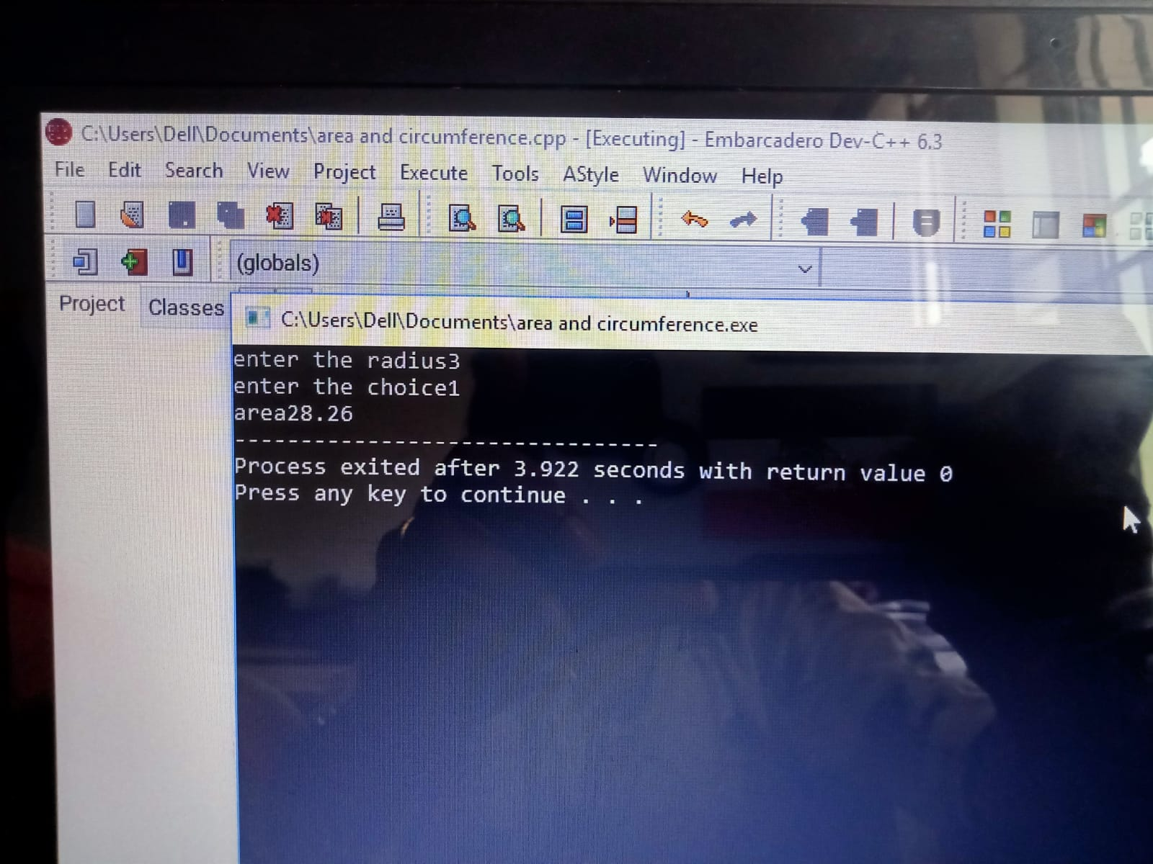

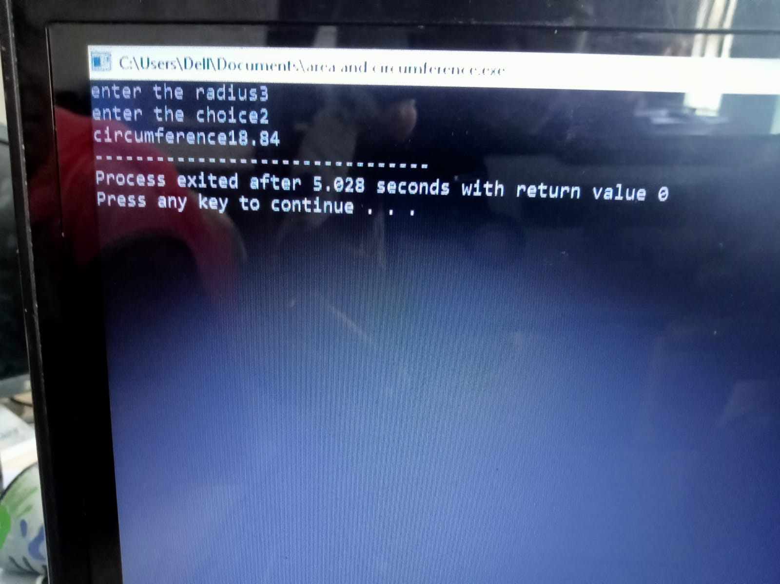

4.write a c++ program for finding the greatest among three numbers?

Conditions:

1.x=5;y=7;z=-9

2.x=0.01;y=0.09;z=-0.03

3.x=-9;y=-7;z=-10

4.x=a;y=b;z=c

Program:

using namespace std;

#include<iostream>

int main()

{

float x,y,z;

cout<<"enter the x,y and z: ";

cin>>x>>y>>z;

if (float(x) && float(y) && float(z))

{

if(x>y && x>z)

{

cout<<"x is the greatest";

}

else if(y>x && y>z)

{

cout<<"y is greatest number";

}

else

{

cout<<"z is the greatest number";

}

}

else

{

cout<<"not valid";

}

}

OUTPUT:

1. 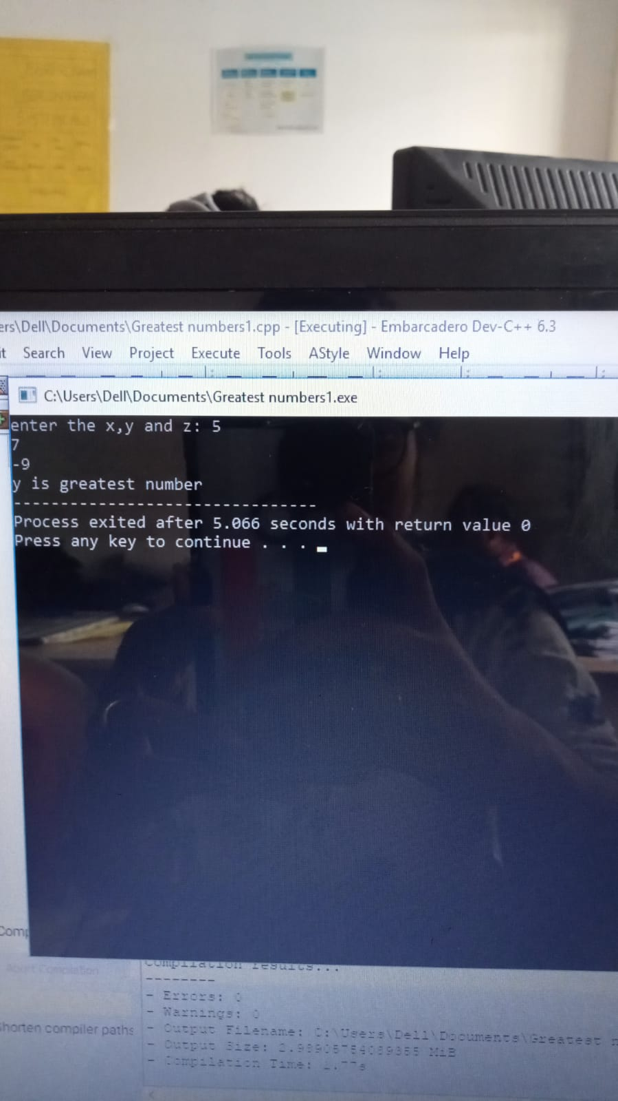

2.

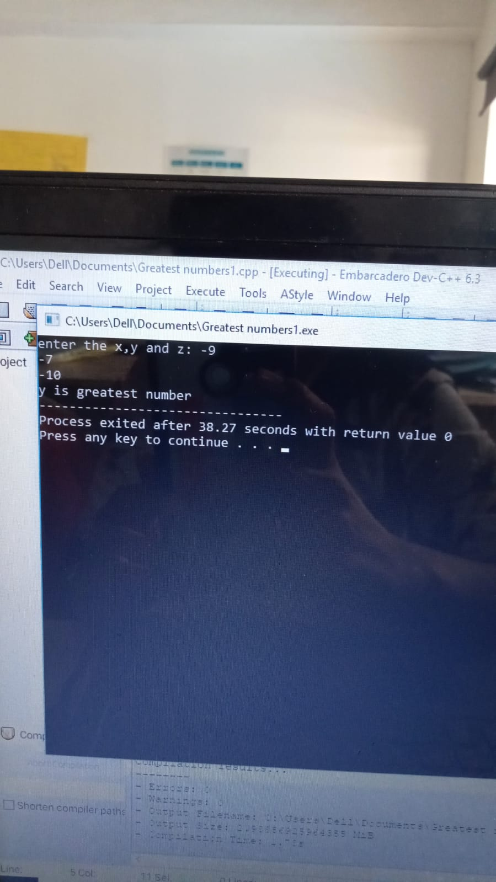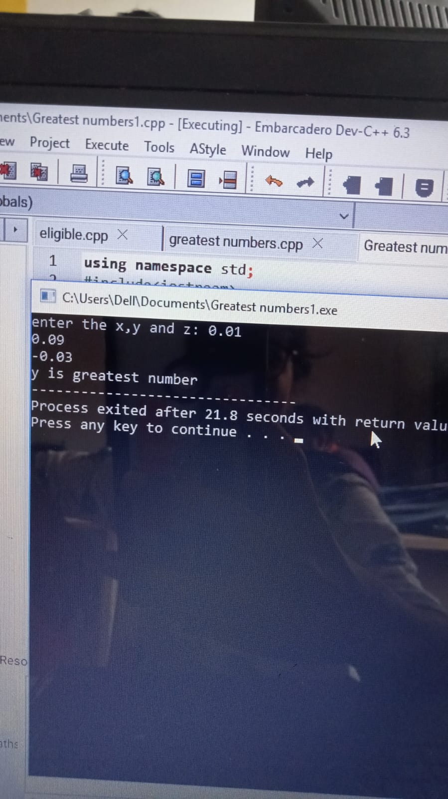

4.

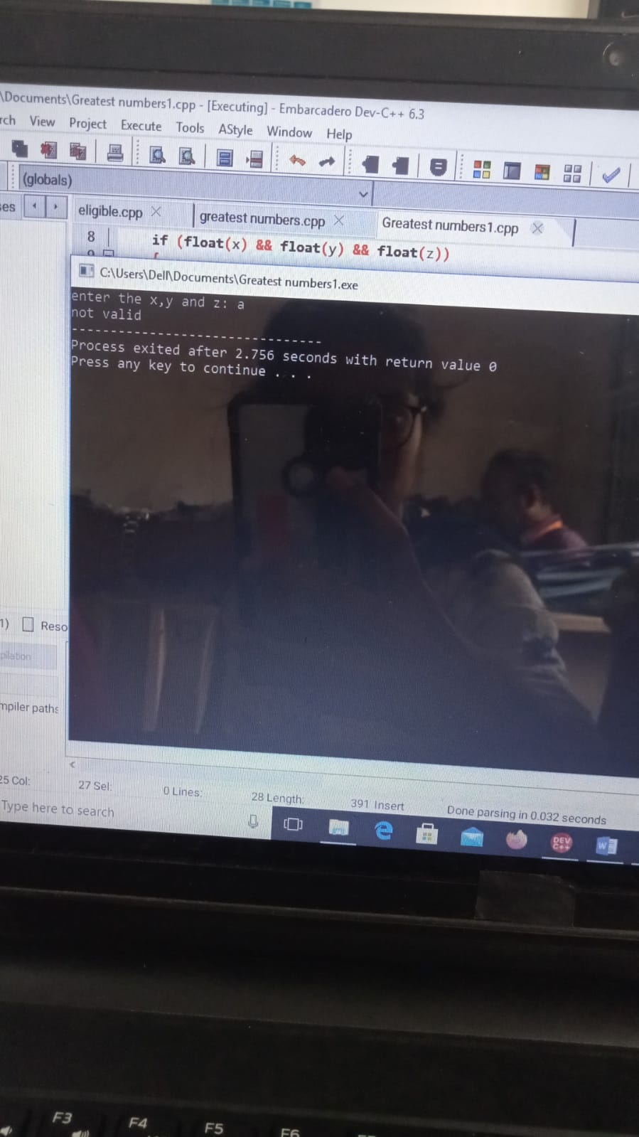

5. Write the c++ program for student report read three marks and calculate the grade?

Conditions:

1. m1=80,m2=60,m3=90;
2. m1=-10,m2=20,m3=100;
3. m1=150,m2=10,m3=100;
4. m1=80,m2=30,m3=60;
5. m1=x;m2=y;m3=z;

Program:

using namespace std;

#include<iostream>

int main()

{

int m1,m2,m3,regno;

float total,avg;

cout<<"enter the regno";

cin>>regno;

cout<<"enter the three subject marks";

cin>>m1>>m2>>m3;

total=m1+m2+m3;

if (m1>=50 && m1<=100)

{

avg=total/3;

if(avg>=90)

{

cout<<"grade A";

}

else if(avg>=80 && avg<90)

{

cout<<"grase B";

}

else if(avg>=70 && avg<80)

{

cout<<"grade C";

}

else if(avg>=60 && avg<70)

{

cout<<"grade D";

}

else

{

cout<<"fail";

}

}

else

{

cout<<"enter the correct marks";

}

}

OUTPUT:

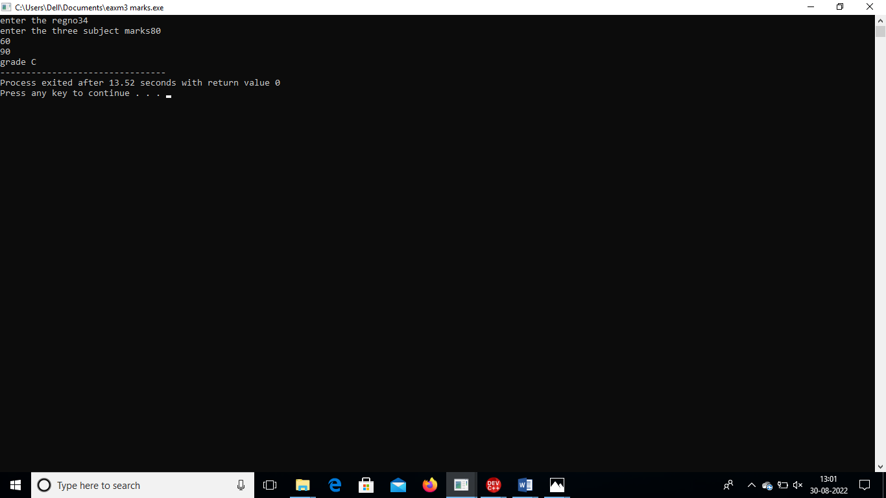

2.  
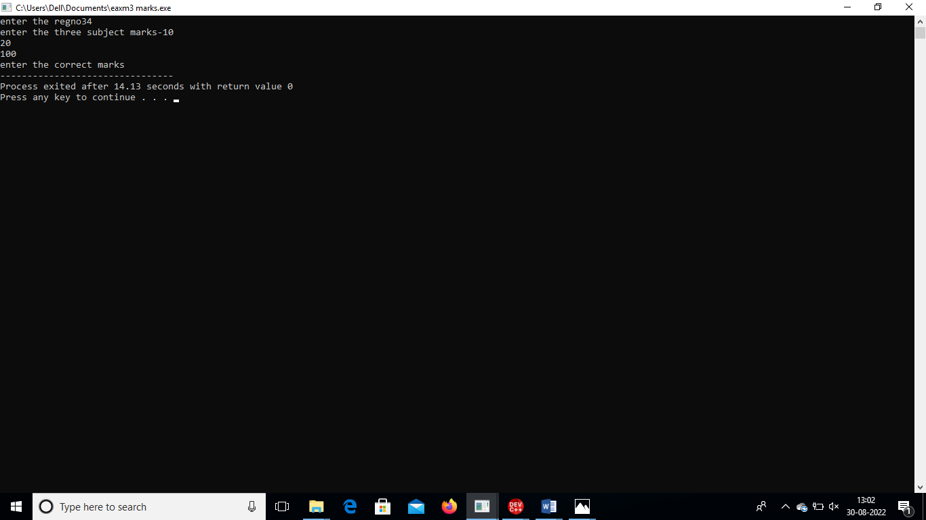

3.

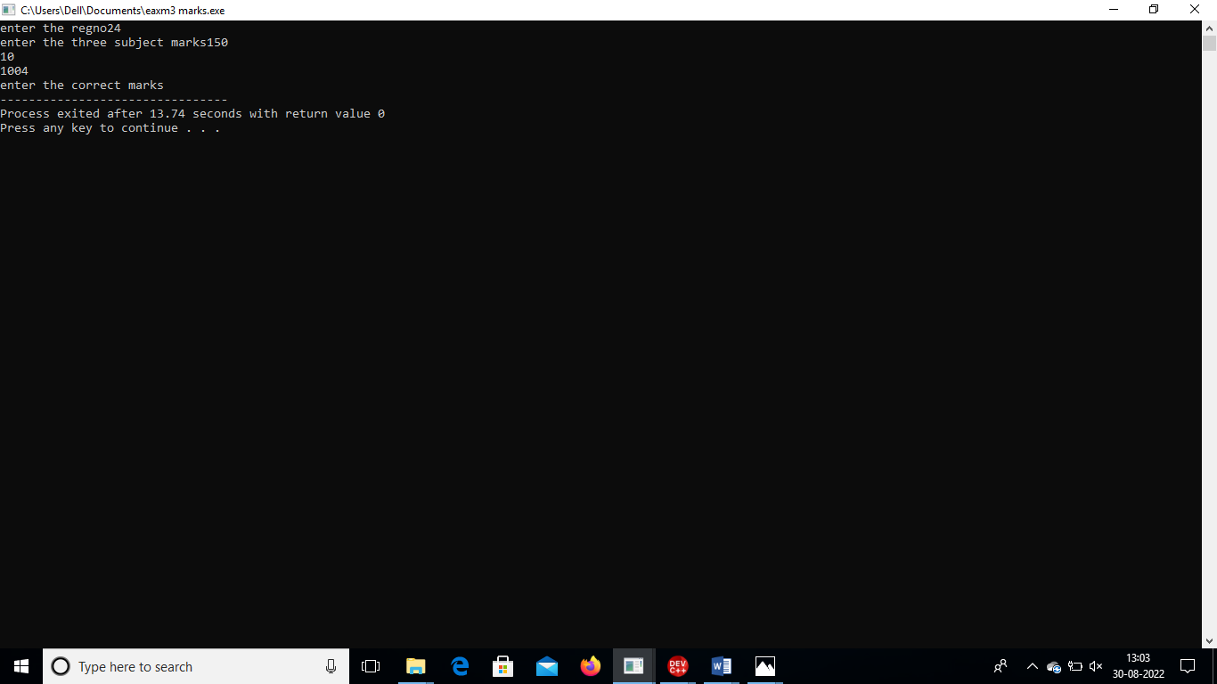

4.

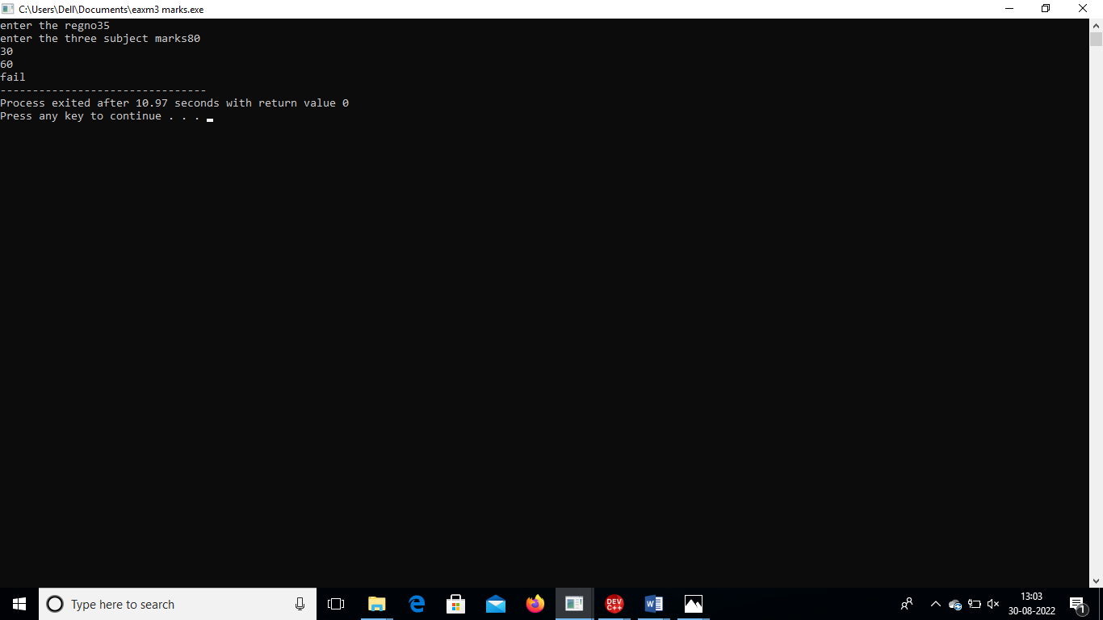

5.

